Core Concepts of Scaling in Kubernetes
- Scaling refers to adjusting the number of servers or workloads to meet demand.
- It can be done manually (e.g., adjusting replicas in a deployment) or automatically (autoscaling).
- Manual scaling is inefficient for large-scale systems with thousands of pods or nodes.
- Autoscaling automates resource adjustment based on workload demand or resource utilization.
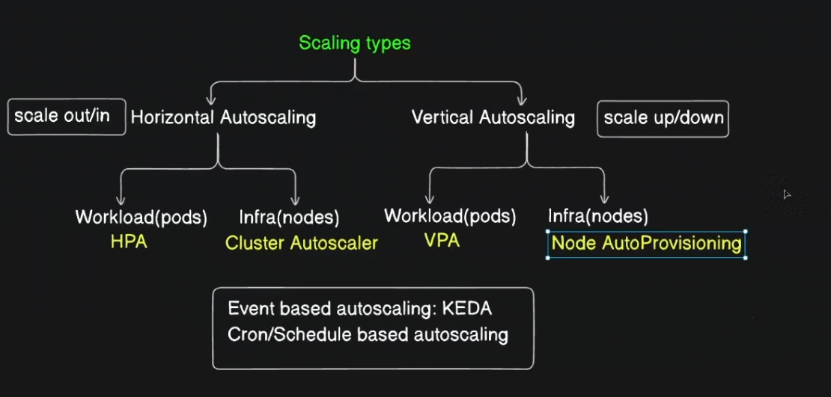

Types of Autoscaling
Scaling Type | Description | Use Case / Notes
Horizontal Pod Autoscaling (HPA) | Automatically adds/removes pod replicas based on workload (CPU, memory, etc.). | Scales out/in pods; ideal for stateless apps needing to handle fluctuating load without downtime.
Vertical Pod Autoscaling (VPA) | Automatically resizes pod resources (CPU/memory) by replacing pods with larger/smaller ones. | Suitable for apps that can tolerate downtime due to pod restarts; not mission-critical workloads.
Cluster Autoscaler | Adds/removes nodes in the cluster based on overall resource demand. | Managed mostly by cloud providers (AKS, EKS, GKE); unavailable for local clusters like Minikube.
Node Auto-Provisioning | Automatically creates node pools or infrastructure resources as needed. | Typically cloud-provider managed; expands cluster capacity dynamically.
Event-Based Autoscaling | Scales based on specific event triggers (e.g., error rates, custom metrics). | Implemented via third-party tools like KEDA (Kubernetes Event-driven Autoscaling).
Schedule-Based Autoscaling | Scales resources based on predefined schedules (e.g., peak hours). | Useful for predictable load patterns, not covered in detail here.

Horizontal vs Vertical Autoscaling
- Horizontal Autoscaling (Scale Out/In):
  - Adds or removes pod replicas to meet demand.
  - Example: Increase pods from 1 to 5 when CPU utilization crosses 60%.
  - Works without pod restarts, ideal for stateless apps.
- Vertical Autoscaling (Scale Up/Down):
  - Changes pod resource limits (CPU/memory), replacing pods with bigger/smaller ones.
  - Requires pod restarts, so suitable only for apps that can afford downtime.

Autoscaling Scope: Workloads vs Infrastructure
Autoscaling Level | Examples | Tools / Kubernetes Components
Workload Level | Pods scaling (HPA for horizontal, VPA for vertical) | HPA (built-in), VPA (external add-on)
Infrastructure Level | Nodes scaling (Cluster Autoscaler, Node Auto-Provisioning) | Cluster Autoscaler (managed cloud services)

Kubernetes Autoscaling Features and Availability
- HPA is built-in within Kubernetes and relies on metrics from Metrics Server.
- VPA is a separate project and requires manual installation.
- Cluster Autoscaler is typically provided by managed Kubernetes cloud services.
- Local Kubernetes setups (e.g., Minikube, kind) generally do not support automatic node scaling.
- Event-based autoscaling is implemented via third-party projects like KEDA.

Demonstration Highlights: Horizontal Pod Autoscaler (HPA)
- Prerequisite: Metrics Server running in the cluster to provide CPU/memory utilization metrics.
- Created a deployment (php-apache) with a single pod, resource requests/limits defined (e.g., 200m CPU request, 0.5 CPU limit).
- Created a service exposing the application on port 80.
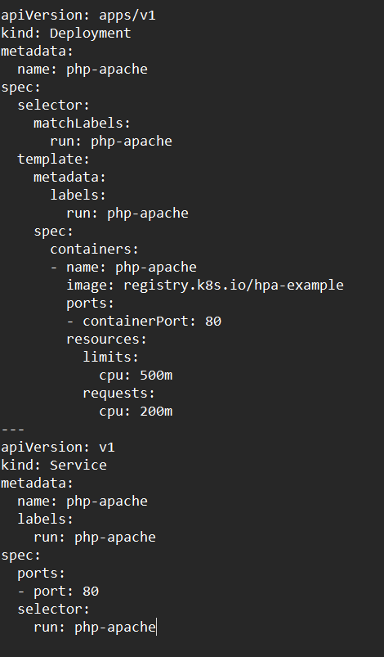

- Used the command kubectl autoscale deployment php-apache --cpu-percent=50 --min=1 --max=10 to create an HPA object. (Imperative method)

Or use declarative method

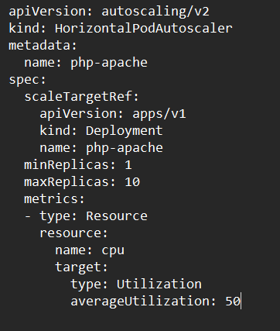

  - This sets the target CPU utilization to 50%.
  - Minimum replicas: 1, Maximum replicas: 10.
- Simulated load using a busybox-based load generator pod sending continuous requests.
kubectl run -i --tty load-generator --rm --image=busybox:1.28 --restart=Never -- /bin/sh -c "while sleep 0.01; do wget -q -O- http://php-apache; done"

- Observed HPA automatically increasing pods from 1 to 5+ as CPU utilization crossed the threshold.
kubectl get hpa php-apache --watch

- After stopping the load test, the number of pods gradually scaled down back to the minimum as CPU utilization decreased.
- When the load drops to zero, the Kubernetes HPA will typically take at least 5 minutes to begin scaling down the deployment. The total time to reach the minimum number of replicas depends on the number of pods and the configured scaling policies. The delay is due to the default scale-down stabilization window of 300 seconds (5 minutes), which is a built-in mechanism to prevent "flapping" (rapid scaling up and down) caused by short-lived metric fluctuations. The HPA controller checks metrics from the Metrics Server every 15 seconds by default. The Metrics Server itself scrapes data from the Kubelet every 60 seconds.

Key Insights
- Autoscaling enhances resource efficiency and availability by dynamically adjusting workloads.
- HPA provides reactive scaling based on real-time CPU/memory metrics.
- Autoscaling decisions are based on average utilization over configurable intervals (default 15 seconds).
- Vertical scaling (VPA) is less common in production due to pod restarts but useful for certain workloads.
- Managed Kubernetes services simplify infrastructure autoscaling (nodes) via built-in cluster autoscalers.
- Event-based and schedule-based autoscaling offer advanced control beyond resource metrics.
- Autoscaling features vary in availability depending on the Kubernetes environment (cloud vs local).

Additional Notes
- Kubernetes version used for demo: v1.30 (latest as of June 2024).
- YAML files used for deployment and service are available on the instructor’s GitHub repository.
- Autoscaling concepts and demo are intended as a learning resource, not directly required for CKA exam.
- Future videos will cover related topics such as pods’ liveness and readiness probes.

Summary Table: Autoscaling Types and Kubernetes Tools
Autoscaling Type | Kubernetes Tool/Feature | Built-in or External | Typical Use Case | Requires Pod Restart?
Horizontal Pod Autoscale | HPA | Built-in | Scale pods out/in based on CPU/memory | No
Vertical Pod Autoscale | VPA | External (GitHub) | Resize pod resources (CPU/memory) | Yes
Cluster Autoscale | Cluster Autoscaler | Managed Cloud | Scale cluster nodes out/in | N/A (nodes scale)
Event-Based Autoscale | KEDA (and others) | External | Scale based on custom events/metrics | Depends
Schedule-Based Autoscale | Various (custom scripts/tools) | External | Scale based on time schedules | Depends
This comprehensive overview clarifies core autoscaling concepts in Kubernetes, practical distinctions between horizontal and vertical approaches, and demonstrates how HPA can be implemented and tested effectively.

